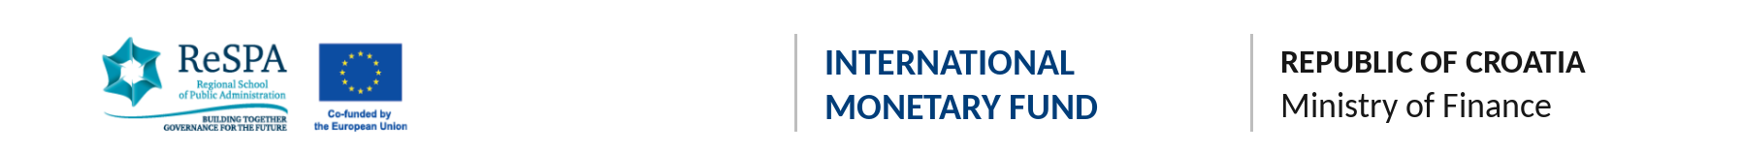

A Capacity-Building Workshop for Public Administrations
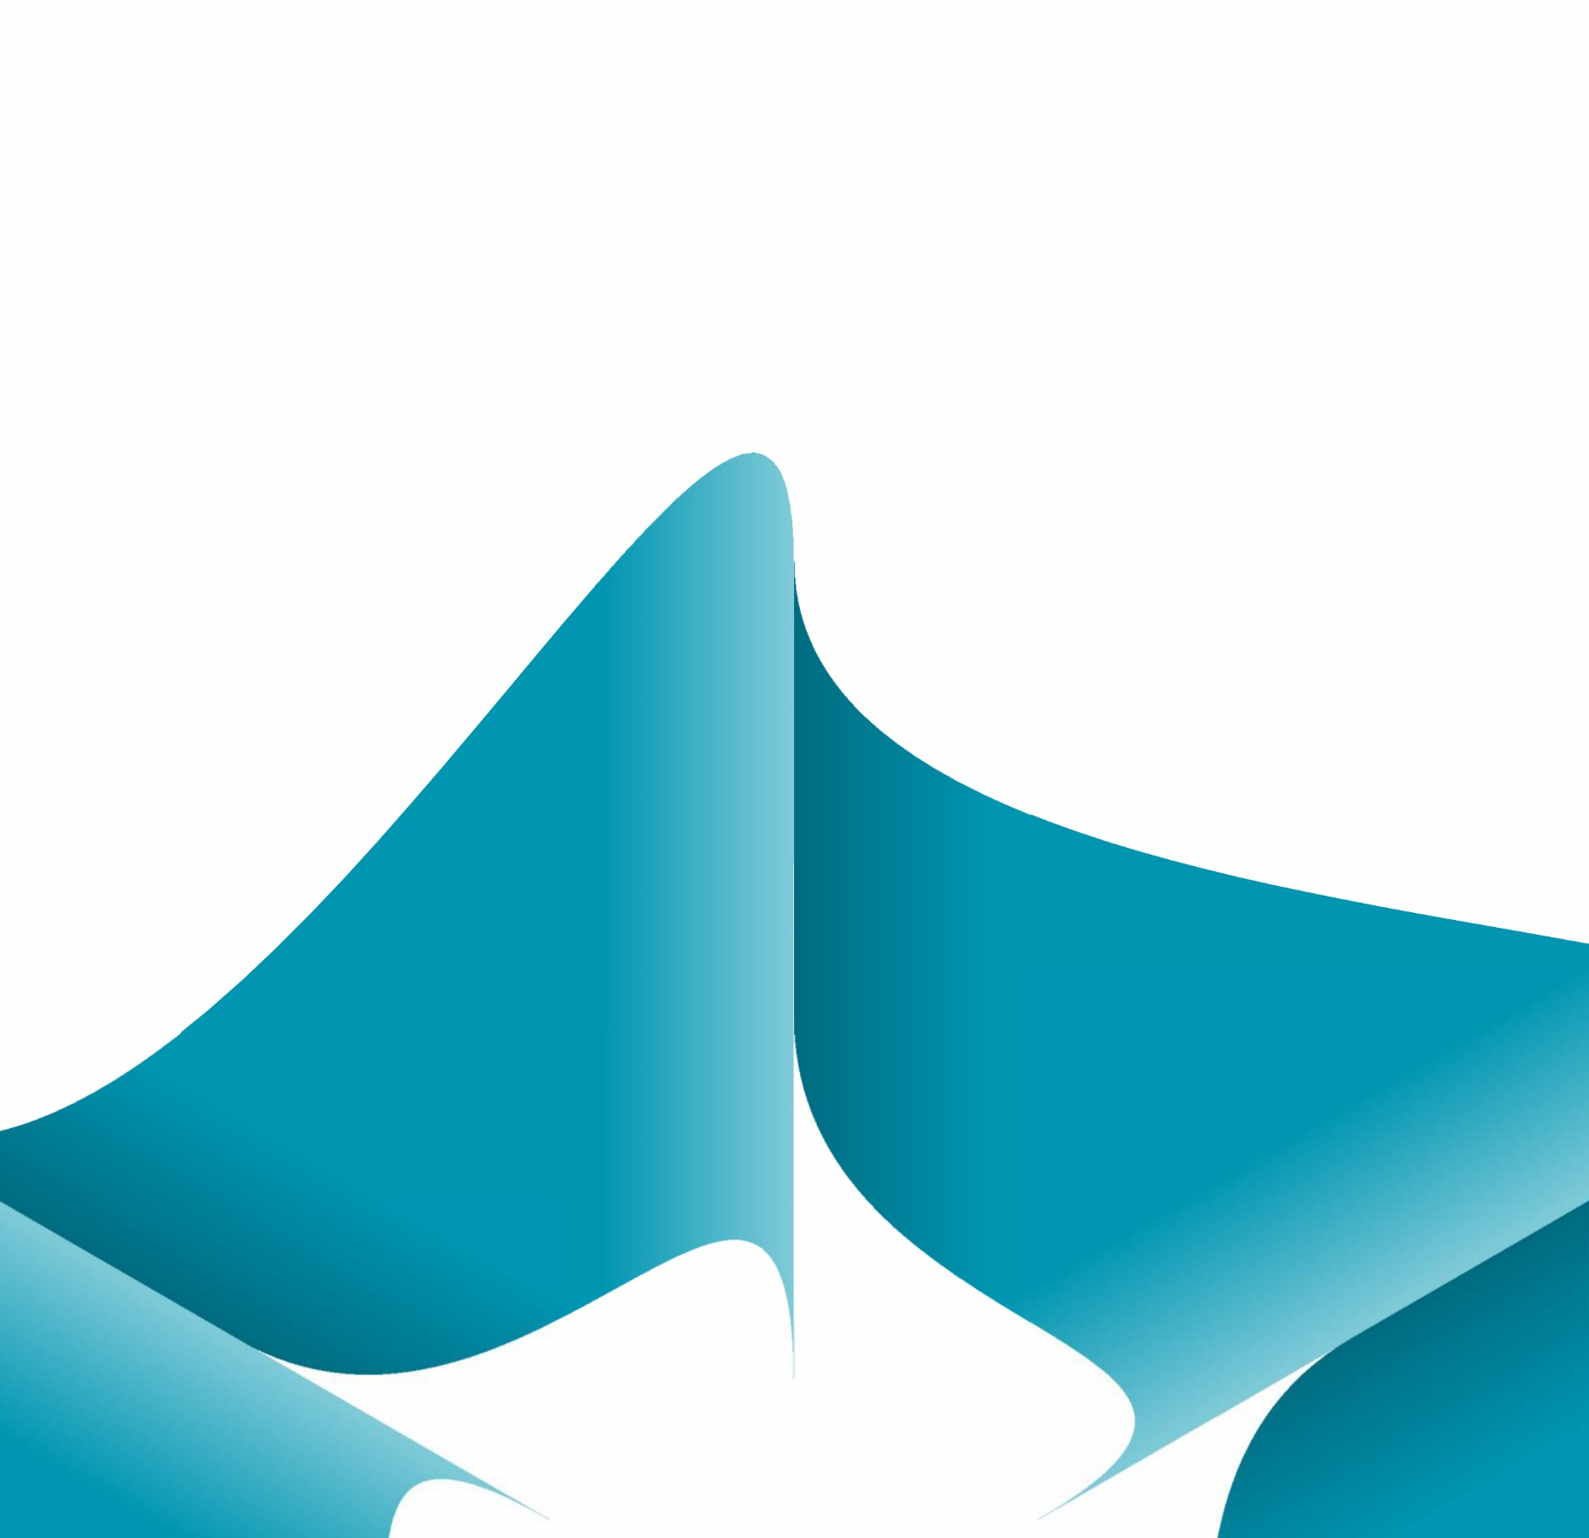
“Smart Investment 4 Strong Governance: Single Project Pipleine and Delivery”
23–24 November 2026
Zagreb, Croatia

Background
Public investment is where public financial management (PFM) turns into roads, railways, energy networks, schools and hospitals, and it is where inefficiency is most costly. ReSPA, in cooperation with the International Monetary Fund (IMF) and hosted by the Ministry of Finance of the Republic of Croatia, is therefore pleased to announce a regional capacity-building workshop in Zagreb. It brings together the public investment management (PIM) units of ministries of finance, central planning bodies and line ministries with large capital budgets from ReSPA Members and Beneficiaries, together with counterparts from Moldova, Ukraine and Armenia.
The workshop responds to three developments. First, the IMF estimates that 31–39% of the potential value of public spending in emerging economies is lost through inefficiency (Fiscal Monitor, October 2025). Second, the IMF Public Investment Management Assessments (PIMAs) for the Western Balkans show that PIM laws, decrees and units have improved, but practice lags behind: the main bottlenecks are project appraisal, project selection, medium-term budgeting and portfolio management. Third, EU funding for infrastructure in the region is growing fast, but delivery is slow. The European Court of Auditors found that of €2.7 billion of EU funds allocated under the Western Balkans Investment Framework between 2015 and mid-2025, only €527 million had been paid (Special Report 16/2026). The workshop is designed to help participants move from PIM rules on paper to projects that are well selected, affordable and delivered on time.
The programme draws on the technical expertise of the IMF Fiscal Affairs Department, including its 2026 internal evaluation of PIMA and the C-PIMA Handbook on climate-responsive investment (November 2025). It also uses SIGMA Paper No. 80 (July 2026), which sets out 11 principles for a Single Project Pipeline in EU candidate countries. The Ministry of Finance of the Republic of Croatia shares the experience of an EU Member State with unified appraisal rules, green budget tagging and delivery of its Recovery and Resilience Plan against hard EU deadlines.
The programme is structured as a working, problem-solving exchange rather than a one-way transfer of knowledge. Before the workshop, each administration completes a short self-assessment against the 11 Single Project Pipeline principles; the results are presented as a regional heatmap. Participants then analyse a real project that ran over time or budget, discuss support options directly with development partners, and translate the discussion into one country-specific reform action that feeds into their own PIM reform agenda, including, where relevant, the reform steps monitored under the Reform and Growth Facility for the Western Balkans and the Ukraine Facility.
Throughout the two days, the discussion will draw on regional evidence and comparative practice, in particular:
- IMF PIMA findings for Albania, Bosnia and Herzegovina, Montenegro, North Macedonia, Serbia and other regional administrations, and the IMF’s analysis of the region’s double challenge of a low public capital stock and low investment efficiency;
- The new PIM units in the ministries of finance of Montenegro, North Macedonia and Serbia, and PIM decrees requiring feasibility studies across the region;
- Ukraine’s Single Project Pipeline, approved by the Strategic Investment Council in 2025 for a recovery effort with needs estimated at US$588 billion over the next decade;
- Albania’s National Single Project Pipeline and the introduction of PIM information systems in Bosnia and Herzegovina and North Macedonia;
- Armenia’s 2023 PIM Decree and Moldova’s PIM reform supported by new IT systems and its 2023 C-PIMA;
- Croatia’s 2022 Budget Law and Government Decree setting unified appraisal rules, including climate criteria, and its green budget tagging introduced for the 2027–2029 budget;
- SIGMA Paper No. 80 on the Single Project Pipeline and the IMF C-PIMA Handbook as reference frameworks for EU candidate countries.
Through this combination of regional evidence and international good practice, the workshop will keep a strong link between PIM policy frameworks and the operational realities faced by ministries of finance, line ministries and project implementing units.
Participants will:
- Examine how a Single Project Pipeline can act as the only entry point into the budget, using the 11 SIGMA principles and the experience of Ukraine and Albania;
- Trace a real infrastructure project through each stage of the investment cycle to identify where it went wrong and which safeguards would have prevented it;
- Explore how to keep projects affordable and on track through multi-year commitment ceilings, maintenance funding and central portfolio oversight;
- Discuss how to integrate climate risk and fiscal risks from PPPs and state-owned enterprises into ordinary investment decisions;
- Put their support needs directly to development partners in a partners’ round table;
- Develop one concrete, country-specific reform action for priority PIM reforms.
This workshop will serve as a platform for regional cooperation, institutional ownership and practical problem-solving.
Participants
The event would bring together representatives of the following institutions from the participating administrations:
- Ministries of finance – PIM units, budget departments and fiscal risk units
- Central planning and coordination bodies responsible for strategic planning and the national project pipeline
- Line ministries and agencies with large capital budgets (transport, energy, environment, health, education)
- Institutions responsible for PIM information systems and for the monitoring of EU-funded investments

Expected Outcomes
By the end of the workshop, participants are expected to:
- Strengthen their understanding of the gap between PIM rules and practice, and of current IMF and SIGMA reference frameworks;
- Understand the principles and preconditions for a functioning Single Project Pipeline linked to the medium-term budget;
- Improve their ability to identify risks of cost and schedule overruns early in the project cycle;
- Strengthen their understanding of portfolio oversight, maintenance funding, and climate and fiscal risk management in public investment;
- Gain a clearer picture of the support available from development partners for PIM reform in 2027;
- Develop a concrete, country-specific reform action, drafted during the Reform Design Lab and refined through peer feedback.
The workshop ultimately supports better selection, budgeting and delivery of public investment, contributing to stronger public financial management, more effective use of EU funds and continued progress in the EU accession process.

AGENDA

DAY 1 – Monday, 23 November 2026
TIME | SESSION
09:00–09:15 | Registration and arrival of participants
09:15–09:30 | Opening Remarks  TBC, ReSPA  TBC, Ministry of Finance of the Republic of Croatia  TBC, IMF
09:30–10:15 | Session 1 – Keynote: Spending Smarter – Why Public Investment Efficiency Matters Now  Speaker: Jamie Carter, Regional Advisor, Fiscal Affairs Department, IMF  What the IMF PIMAs show for the region: PIM laws and procedures have improved, but appraisal, selection, medium-term budgeting and portfolio management lag behind. The keynote also covers where the IMF is heading after its 2026 evaluation of PIMA: a stronger focus on project delivery, investment by state-owned enterprises, and climate. The session closes with the live results of the pre-workshop self-assessment, presented as a regional heatmap.  Keynote & Live Heatmap
10:15–10:45 | Coffee Break
10:45–12:15 | Session 2 – Lightning Round: Where We Stand on PIM Reform  Moderator: TBC, Fiscal Affairs Department, IMF  Representatives of the nine participating administrations each have 5 minutes and three slides: one achievement, one bottleneck and one request for support. The moderator then leads a discussion on patterns across the region, such as central PIM units, feasibility study rules, PIM information systems and project pipelines.  Lightning Presentations & Moderated Discussion
12:15–13:15 | Lunch
13:15–14:30 | Session 3 – One Door into the Budget: The Single Project Pipeline  Speakers: TBC, OECD/SIGMA;  Presentation of SIGMA Paper No. 80 (July 2026): a single, government-wide pipeline of appraised projects that covers all sectors and funding sources, and 11 principles for running it. These include screening ideas early, independent quality review at entry, funding decisions within the medium-term budget, and the freedom to stop projects despite sunk costs. Ukraine and Albania share what works in practice and what does not.  Presentations & Discussion
14:30–14:45 | Coffee Break
14:45–16:15 | Session 4 – Project Autopsy Clinic: Where Did It Go Wrong?  Case presentation: TBC, Finance Directorate of Brčko District, Bosnia and Herzegovina  Facilitator: TBC, Fiscal Affairs Department, IMF  A real infrastructure project that ran over time or budget is presented, based on its ex-post audit. Groups trace it through each stage (concept, appraisal, selection, budgeting, procurement and implementation), identify where it went wrong, and say which pipeline principle would have caught the problem. Each group reports its main lesson in plenary.  Case Presentation & Group Work
16:15–16:30 | Wrap-up of Day 1

DAY 2 – Tuesday, 24 November 2026
TIME | SESSION
09:00–09:15 | Registration and arrival of participants
09:15–10:30 | Session 5 – From Budget to Build Asset: Delivering on Time and on Budget  Speakers: TBC, Ministry of Finance of the Republic of Croatia; TBC, EU Member State Ministry of Finance (portfolio management)  How to keep approved projects affordable and on track: the total cost of each project in budget documents, ceilings on multi-year commitments, maintenance funding, and central monitoring of the portfolio so that delays and cost overruns are dealt with early. Croatia shares how it introduced unified appraisal rules under its 2022 Budget Law and how it has managed delivery of its Recovery and Resilience Plan. Participants then discuss at their tables how their administrations deal with stalled projects and under-funded maintenance.  Presentations & Table Discussion
10:30–11:30 | Session 6 – Partners’ Round Table: Who Supports What?  Invited: TBC, European Commission (DG ENEST / WBIF); TBC, IMF; TBC, World Bank; TBC, EIB/JASPERS; TBC, EBRD (at least three different partners)  Moderator: TBC, ReSPA  The administrations put the support requests from the lightning round directly to the partners. Each partner explains, briefly and concretely, what support is available in 2027 for project preparation, appraisal capacity, PIM information systems and pipeline management, followed by an open exchange with participants.  Round Table
11:30–11:45 | Coffee Break
11:45-13:00 | Session 7 – Reform Design Lab: One Action per Administration  Facilitators: TBC, IMF; TBC, ReSPA  Each administration uses its self-assessment and the workshop discussions to choose one priority action, such as a pipeline register, appraisal thresholds, independent review at entry or a maintenance benchmark. Peer feedback helps define the responsible institution, the first step and the support needed.  Group Work & Peer Review
13:00-13:15 | Closing Session: Key Takeaways  Moderator: TBC, ReSPA
13:15-14:00 | Lunch

Note: the agenda is preliminary and subject to confirmation; session order and speakers will be finalised closer to the workshop

